Milestone 2
John McIntyre
CST-451 Capstone Project Requirements Document
Grand Canyon University
Instructor: Professor Mark Reha

ABSTRACT

McIntyre Fitness is a desktop application that is designed to help users track completed workouts, monitor fitness progress, and achieve health goals. The application allows users to log exercises and also view detailed progress reports. A big focus point with this application is ensuring user friendliness.
The purpose of this project is to design a system that meets user needs in a simple and effective way. This includes features like tracking workouts and showing progress over time. It also includes making sure the app runs smoothly, is easy to use, and keeps user data safe. The project also looks at how the system will be set up, including how users will interact with it and how the data will be stored and used.
This project creates a plan for building the McIntyre Fitness application. It shows how a fitness app can help people stay on track with their goals. In general, apps like this are becoming more popular because they make it easier for people to manage their health and fitness in one place.

History and Signoff Sheet
Change Record
Date | Author | Revision Notes
03/29/2026 | John McIntyre | Initial draft for review/discussion
07/19/2026 | John McIntyre | Final update Billing requirement removed from scope. phpMyAdmin replaced with MySQL Workbench. Password hashing, UI redesign, progress chart, date filter, logout, delete confirmation, and motivational messages added in CST-452.

Overall Instructor Feedback/Comments
Was instructed to clean up project documentation and change scope because it would make documentation harder for CST-451. I did end up doing that and it did help.

Overall Instructor Feedback/Comments
Integrated Instructor Feedback into Project Documentation
☒ Yes ☐ No

TABLE OF CONTENTS
Functional Requirements 4
Non-Functional Requirements 5
Technical Requirements 6
Logical System Design 7
User Interface Design 8
Reports Design 9

Functional Requirements
Use Cases
Describe the sequence of functional actions a project performs with either textual Use Cases, UML Use Case diagrams, or if using Scrum, provide a link to the User Stories (see template included in course materials).
NOTE: Once the functional requirements have been completed, there may be situations where Use Cases or User Stories may need to be taken out of scope, possibly due to technical challenges or timeline challenges. Any Use Cases or User Stories that are taken out of scope once the project development has started must be approved by the mentor and instructor with justification as to why the functionality is being removed from the project. The following must be updated if any Use Cases or User Stories are taken out of scope:

Use Case or User Story | Approval Date | Justification
As a user I would like to create an account. |  | Needed so users can have a personal profile and track their workouts.
As a user I would like my account to be secure. |  | Protects user information and personal data from unauthorized access.
As a user I would like to log completed workouts. |  | Allows users to track their exercise history and progress.
As a user I would like to edit or delete workouts. |  | Lets users correct mistakes or remove unnecessary entries.
As a user I would like to view my progress over time. |  | Helps users see improvements and stay motivated.
As a user I would like to enter exercise details such as type, duration, and calories. |  | Provides accurate tracking and meaningful fitness insights.
As a user I would like to receive workout suggestions or reminders. |  | Encourages consistent exercise and helps users meet goals.
Users must be able to view billing data |  | Allows users to see payment history or subscription information if applicable.

NOTE: If necessary, you may add subsections to those listed in order to match the requirements in the assignment description. Do not remove any top-level sections (those that are listed in the Table of Contents). As required by your project, you may add additional top-level sections (please update the Table of Contents).

Non-Functional Requirements
Use Cases
Describe the sequence of non-functional actions a project performs with either textual Use Cases, UML Use Case diagrams, or if using Scrum, provide a link to the User Stories (see template included in course materials).

NOTE: Once the non-functional requirements have been completed, there may be situations where Use Cases or User Stories may need to be taken out of scope, possibly due to technical challenges or timeline challenges. Any Use Cases or User Stories that are taken out of scope once the project development has started must be approved by the mentor and instructor with justification as to why the functionality is being removed from the project. The following must be updated if any Use Cases or User Stories are taken out of scope:

Use Case or User Story | Approval Date | Justification
The app should open quickly, ideally under 2 seconds. |  | So users can start using the app immediately without waiting.
All user information must be stored securely and encrypted |  | Protects personal data from unauthorized access and ensures privacy.
The system should remain operational and not crash. |  | Ensures reliability and prevents loss of user data.
The interface should be simple and easy to use for any user. |  | Makes the app accessible and reduces confusion for users.
When errors occur, the app should display clear and helpful messages. |  | Helps users understand and fix problems quickly.
The app should respond to user input within 1 second for all actions. |  | Provides a responsive user experience.
The app should use minimal system resources to avoid slowing down the computer. |  | Ensures the app runs efficiently without affecting other programs.

Technical Requirements
Use Cases
Describe the tools and technologies used in the project.

NOTE: Once the technical requirements have been completed, there may be situations where technologies or tools may need to be taken out of scope or changed, possibly due to technical challenges or timeline challenges. Any technologies or tools that are taken out of scope or changed once the project development has started must be approved by the mentor and instructor with justification as to why the functionality is being removed from the project. The following must be updated if any technologies or tools are taken out of scope or changed:

Technology or Tool | Approval Date | Justification
Visual Studio |  | IDE used to write and test the application code.
C# |  | Programming language used for the desktop application.
MySQL |  | Database system to store user accounts, workouts, and progress data.
phpMyAdmin |  | Tool to manage the MySQL database locally.
Windows 11 |  | Platform where the application will be installed and run.
GitHub |  | Version Control
.NET Framework |  | Provides libraries and runtime needed to run the C# application.
The McIntyre Fitness application will be ran on Windows 11 and will be developed using the Visual Studio IDE. The application will be written in the C# language with the .NET Framework which has all the libraries and tools needed for the user interface, database, and application features. User accounts and there information will be stored in a MySQL database which will be managed by phpMyAdmin. GitHub will be used for version control.

Logical System Design
Provide a diagram of the logical architecture of the system.

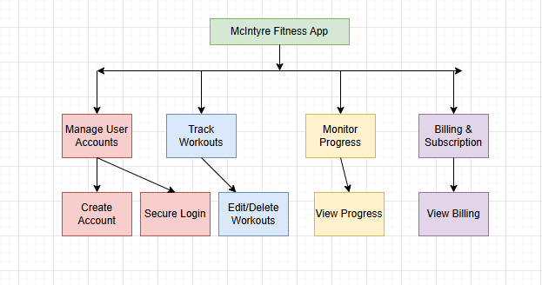
User Interface Design
Provide a sitemap and user interface design diagram for each user interface screen in the application, if not applicable, define the components of the project as described in the handbook.

User Accounts
Login:
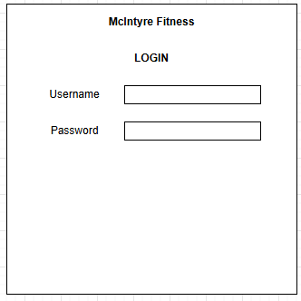
Register:
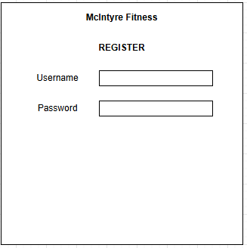

Workouts
Log Workout:
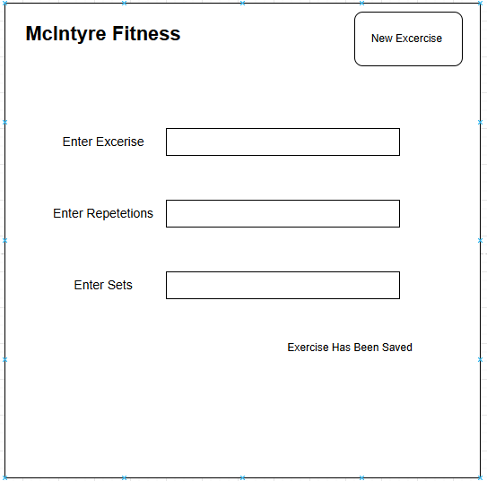
Edit/Delete Workout:
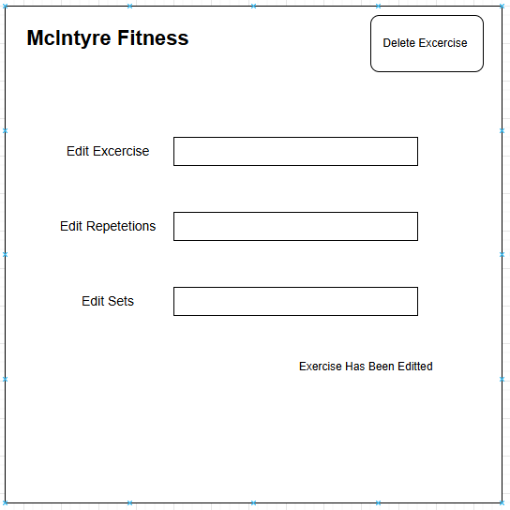

View Workout History:
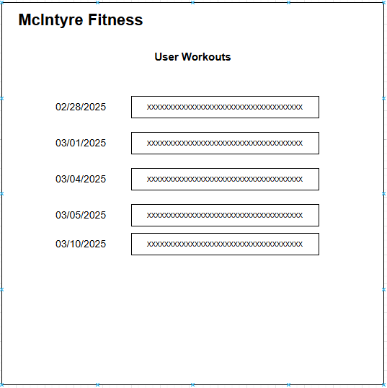

Progress
View Progress / Notifications:
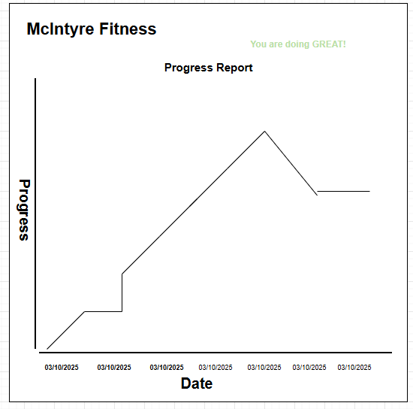

Billing
View Billing Data:
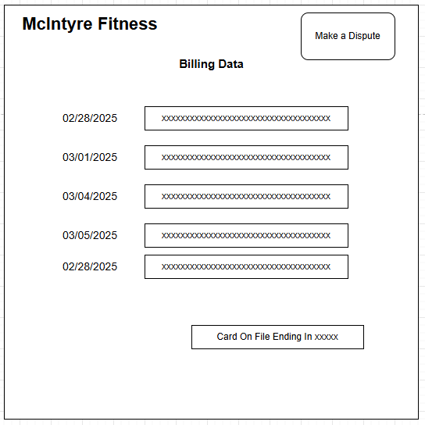

Sitemap
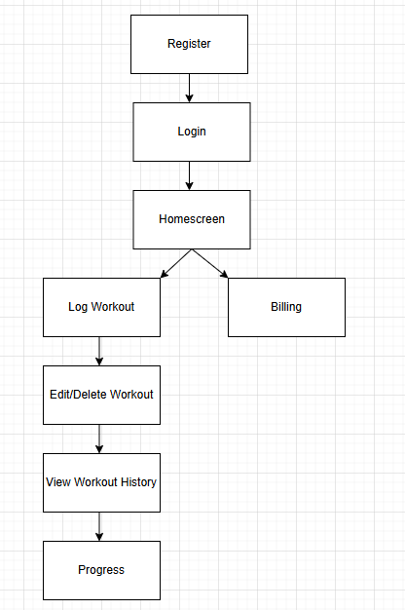

Reports Design
Provide a listing of the reports that the system will provide, if applicable. If not, state that the system does not produce any reports and provide additional documentation as described in the handbook.

Report | Purpose | Data | Format | Frequency
Workout History | Allows user to see completed workouts. | Exercise type, date, and time. | Table view | On demand
Progress Report | Allows users to see there progress. | Date and progression statistics | Line chart | On demand
Billing Report | Allows users to see there financials. | Payments and under what card | Table view | On Demand

Security

The McIntyre Fitness application stores user account information, user workout data, and billing information locally. To ensure that users data is protected all data and sensitive information like passwords and card information will be encrypted in the MySQL database. If a user would like to view sensitive information like billing or workout activity, they must be properly authenticated. Even though the application is locally hosted it is still important that everyone’s data is safe and secure. When new security risks are exposed or identified action will be taken immediately.

Security Matrix
Feature | Admin | User
Create/Edit/Delete Account | Yes | No
Log Workouts | Yes | Yes
View Progress | Yes | Yes
Delete Workouts | Yes | Yes
View Billing Info | Yes | Yes
Manage Database | Yes | No

